**Pet Health and Wellness Tracker**

Group-10

HSIAO-KANG CHANG

Tables chosen: Owners, Pets and Vaccinations

**Yunjeong Choi**

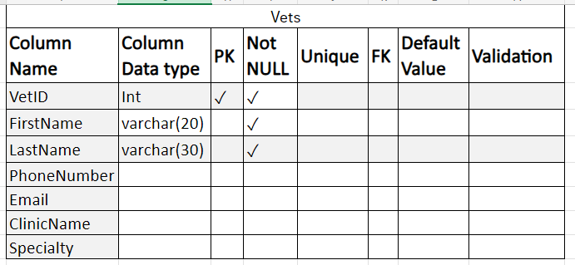 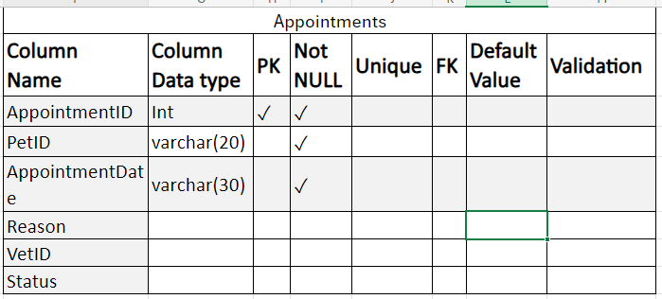

Sin Kau Chu

